Usage and Interfaces to other Systems and for future extensions

Content:

Usage and Interfaces to other Systems and for future extensions 1
User Interface Components 1
Setup Interface 1
Interface for users 1
Interface for Partners and Companies 1
Rest Webservice Interfaces for external usage 1
Webservices for Mobile Clients 1
Webservices for points of sales(POS) 1

User Interface Components

Setup Interface
For an initial setup of the database and to add some needed Informations there is an Webservice you can call over an AJAX enabled page on http://localhost:8080/clearinghouse/service.html
This Service returns “Result: SUCCESS” if the Setup Method works.
Otherwise it returns the stack trace of the produced exception.

Interface for users

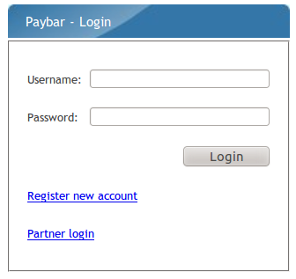
Login
Under the URL http://localhost:8080/clearinghouse/cpanel/ users can find the Login screen for the User Management Interface.
If you use the standard setup method you are able to log in whith the following credentials: user: „user-3“ Password: „hallo123“
On the bottom there is a Link to the Interface for partners and companies described in the next section.

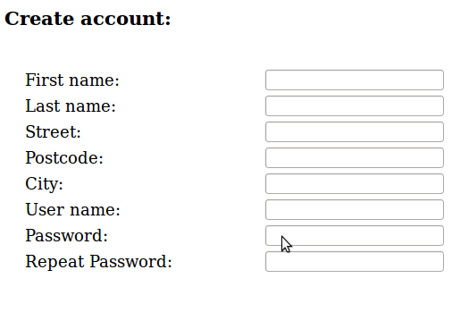
Registration screen
This screen provides the standard functionality to provide and validate user information and calls the internal user registration web service. It validates the password if the password meets the given constraints (in our case the password must have a minimal length of 5 characters) and for the equality with the repeated password.

Wecome Screen
This screen is the landing page after login. It may offer the possibility to inform the user about important changes in the system, legal advice or general information and hints.

Account overwiew
In this screen the user is able to view his or her general informations. At the bottom we provide a link to a form where the user is able to change the given information and the password.

Charge money
Here we have a mockup of a charging functionality. In a real system we would use a standardized form of a partner banking house or a credit card company to handle transactions.

Transaction Overwiew
In this view we get a list of all the transactions

Lock Devices

Logout

Interface for Partners and Companies

Rest Webservice Interfaces for external usage

Webservices for Mobile Clients

Webservices for points of sales(POS)

